Lesson 29. HPA in K8s
- Scale la qua trinh mo rong hoac thu nho he thong de dap ung duoc tot hon nhu cau su dung khi nhu cau su dung, khoi luong cong viec tang giam.
- Nhung tac nhan lam cho du an bi cham se co rat nhieu yeu to nhu la CPU, Memory, Network, Disk I/O, Load Balancer,…
- Tang giam CPU, Ram cho du an se co 2 loai la Vertical Scaling (tang ve chieu doc, scale up / down): tang su manh cua 1 may/instance va Horizontal Scaling (tang ve chieu ngang, scale out/in): them so luong instance => tang tai nguyen cua server.
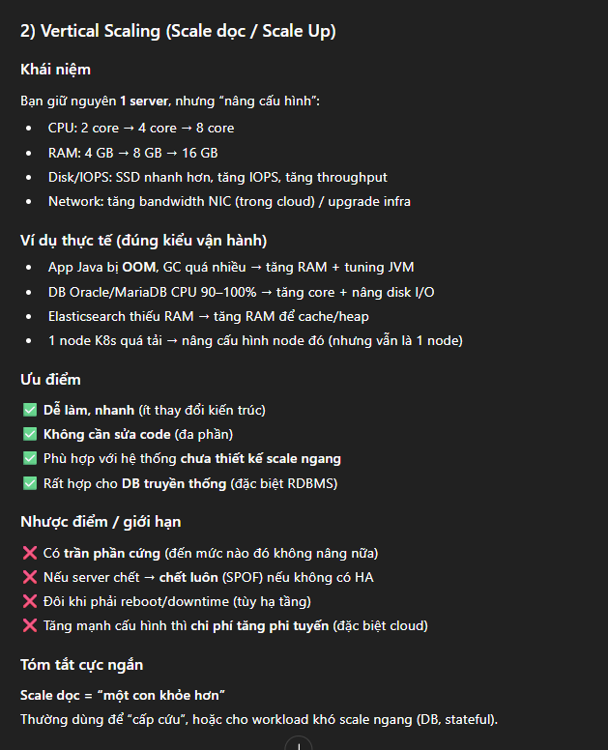
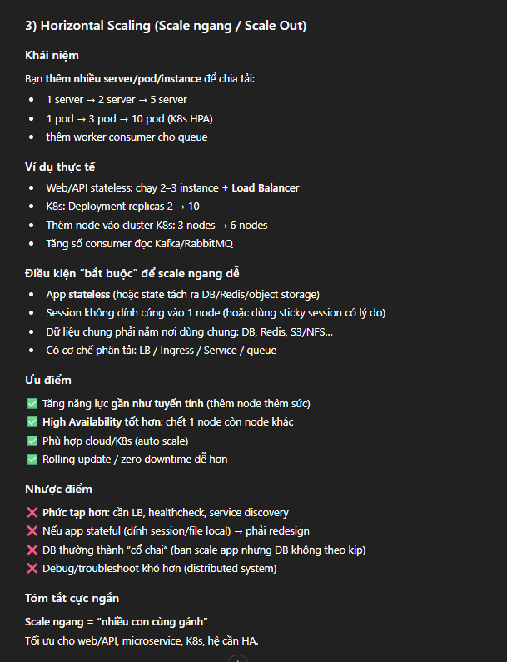
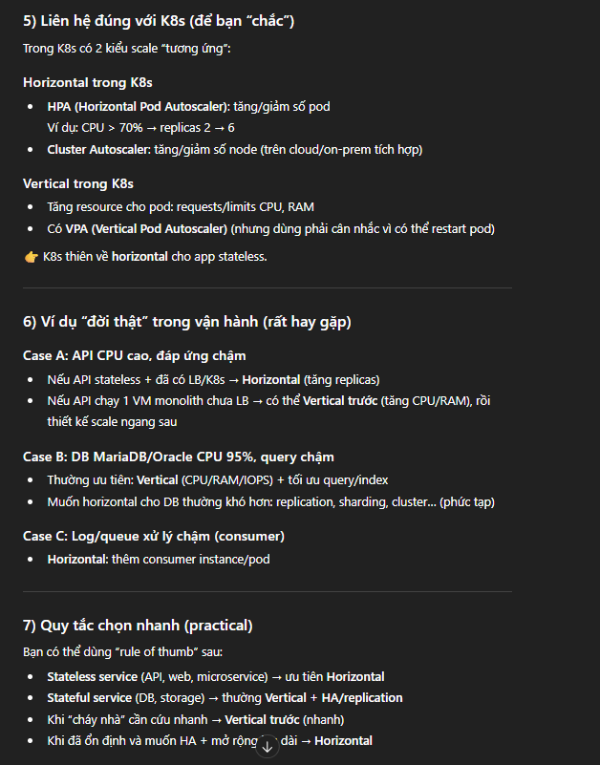
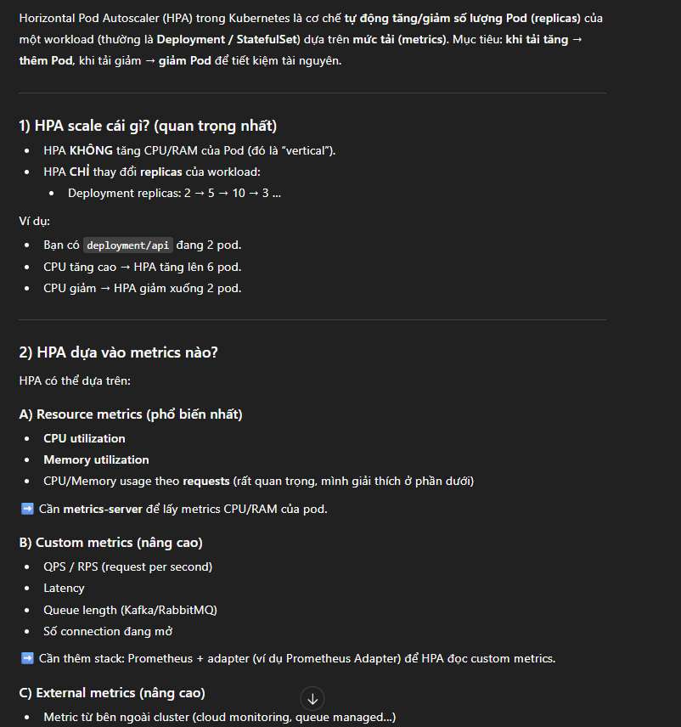
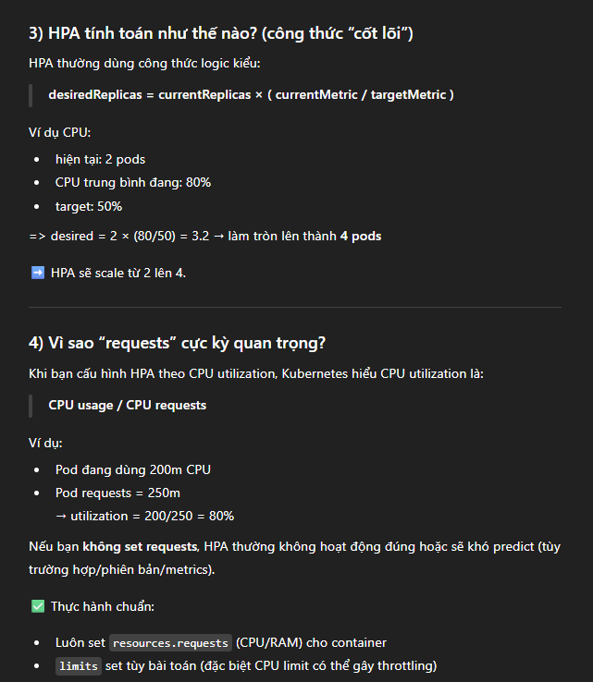
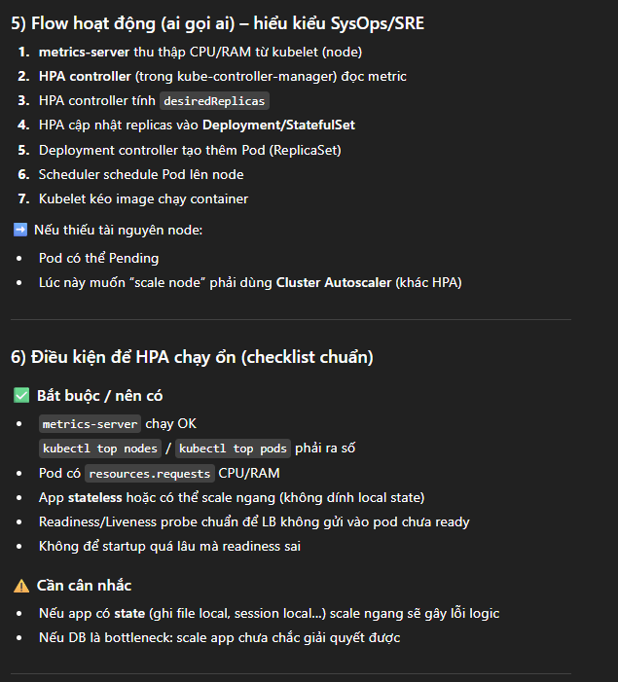
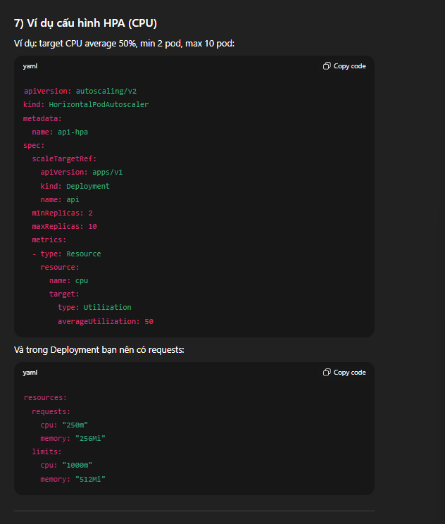
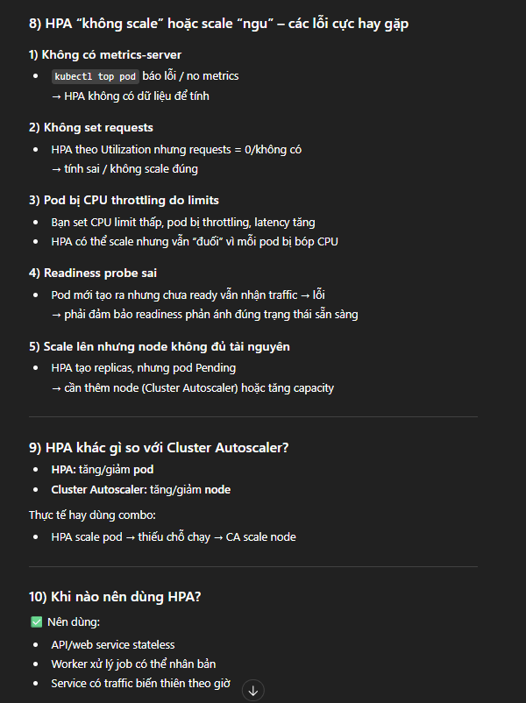
=> Cai dat metric server len K8s hoac su dung helm chart.
=> Tren server k8s-master-1 => add repo de su dung metrics-server.
learn-k8s@k8s-master-1:~$ helm repo add metric-server https://kubernetes-sigs.github.io/metrics-server/ => addrepo, metric-server => them repo tu dat
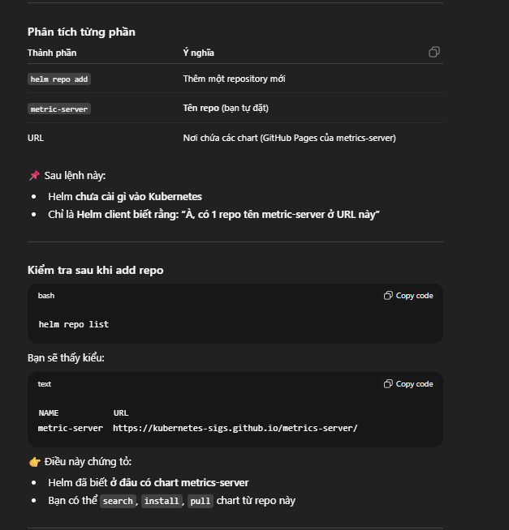

learn-k8s@k8s-master-1:~$ helm pull metric-server/metrics-server => pull metric server

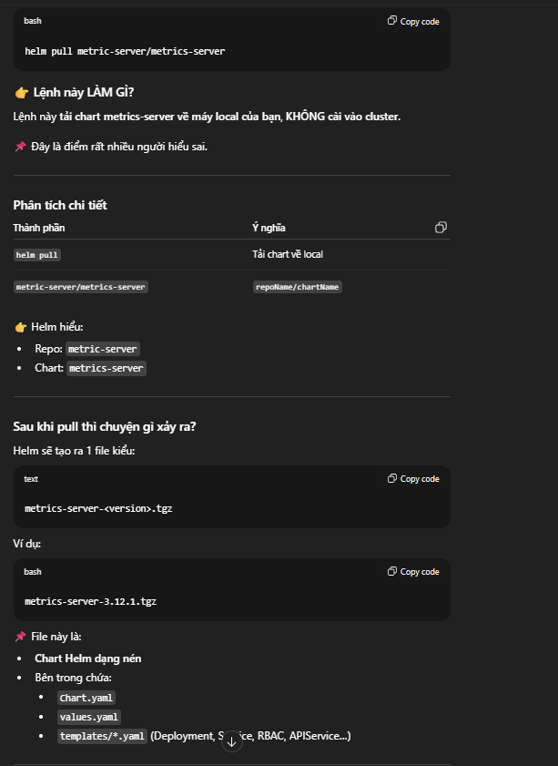
learn-k8s@k8s-master-1:~$ tar -xvf metrics-server-3.13.0.tgz => giai nen.
learn-k8s@k8s-master-1:~$ helm install metric-server metrics-server -n kube-system => metric-server => release name (ten ban cai/ instance cua chart), metrics-server, metrics-server => chart name, -n kube-system => cai vao namespace.
=> Sau khi cài vào rancher sửa lại file config yaml deployment sửa lại tls = true, port = 4443
=> Metric server se thu thap va luu tru => metric server monitor k8s cluster
=> learn-k8s@k8s-master-1:~$ kubectl top nodes
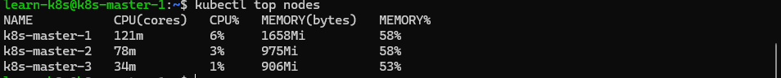
=> Kiem tra cac pod trong 1 namespace => learn-k8s@k8s-master-1:~$ kubectl top po -n ecommerce
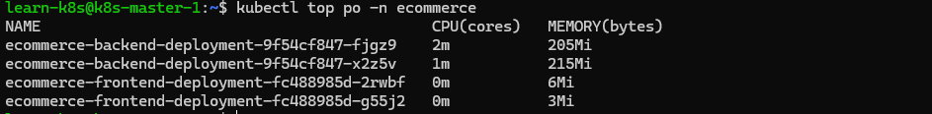
=> File config yaml deployment khi them HPA K8s:
apiVersion: autoscaling/v1
kind: HorizontalPodAutoscaler
metadata:
name: ecommerce-backend-autoscaling
namespace: ecommerce
spec:
scaleTargetRef:
apiVersion: apps/v1
kind: deployment
name: ecommerce-backend-deployment
minReplicas: 2
maxReplicas: 4
targetCPUUtilizationPercentage: 50

=> Chon namespace la ecommerce

